Understanding Your Child’s ACT Aspire™ Results
The ACT Aspire™ student score report contains information about your child’s academic progress. Please remember that due to the possibility of measurement error, scores are estimates, not precise measures of achievement. This guide will help you understand and use information on the score report to help your child. For additional information about ACT Aspire™, please visit www.discoveractaspire.org. Go to http://www.discoveractaspire.org/parent-overview/ for a more complete guide to understanding your child’s ACT Aspire™ results.
Answering the Essential Questions
- What is ACT Aspire™?
ACT Aspire™ is an assessment that measures academic achievement in the areas of English, math, reading, science and writing. It is aligned to the ACT College and Career Readiness Standards, making test results meaningful by connecting your child’s score to specific skills and knowledge that are important for success in college and the workplace.

- Where does my child stand right now?
The ACT Aspire™ student report shows your child’s strengths and weaknesses in up to five subject areas: English, math, reading, science, and writing. In spring of 2014, Alabama required all students to take reading and math, but your child’s school may have elected to administer additional assessments. The report also shows how your child performed in specific skill areas within each subject. Additionally, you can see how your child’s scores compare to those of other students who have taken ACT Aspire™.

- Is my child on target for college and career readiness?
The score indicates how well your child did in each subject area. The three-digit score is based on the actual number of questions answered correctly and the total number of points earned. The score will fall into one of three readiness levels: Ready, Close or In Need of Support. Students scoring in the Ready category are considered on target for college and career readiness. Students scoring in the Close or In Need of Support category may need additional help to reach their goal of being ready for college or the workplace.

Interpreting ACT Aspire™ Reports
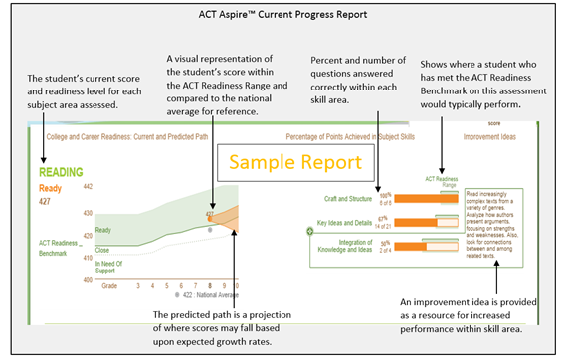
Supplemental Scores Report
The National Percentile Rank shows the percentage of other students in the same grade level who received a score that is the same or lower. For example, a rank of 76 means that your child scored at or better than 76% of other students in the same grade level who took the assessment.
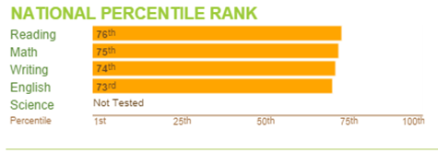
SAMPLE

Sample Report
- The English Language Arts score is a combined score that averages the English, Reading, and Writing test scores. All three subject area assessments must be taken to receive a score.
- The Progress with Text Complexity indicator identifies whether a student is making sufficient progress toward reading and understanding increasingly difficult texts. A ‘Yes’ indicates that a student is likely ready to read more difficult stories and texts that he or she will encounter at the next grade level. A ‘No’ in this area usually means that a student is struggling to understand the meaning and purpose of what was read.

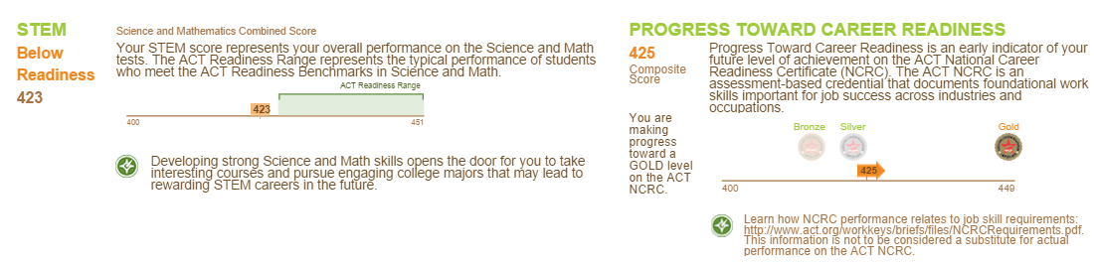
- The Science and Mathematics (STEM) Combined Score is an average of the Science and Mathematics test score. To receive a STEM score, a student must take both the Science and Mathematics assessment.
- The Progress Toward Career Readiness indicator uses an average of your child’s English, Mathematics, Reading, and Science test scores, to project a future ACT National Career Readiness Certificate™ achievement level. This score and indicator are provided for 8th grade students who took each of the four subject area assessments. For more information, please visit http://www.act.org/certificate/about.html.
Sample Report

